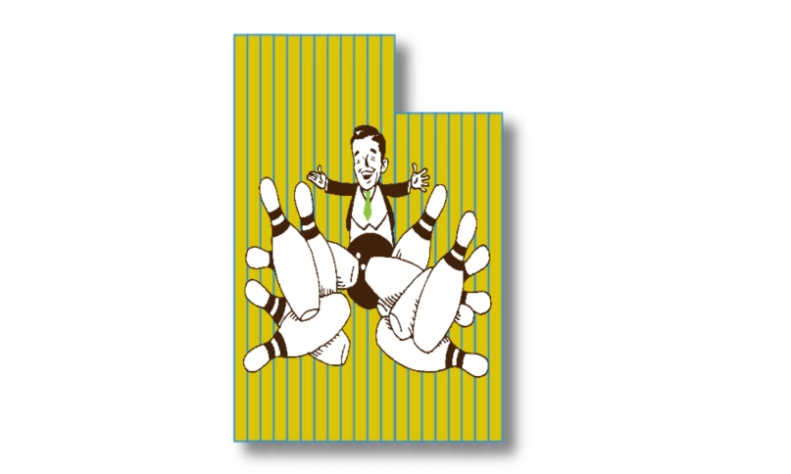
Bonwood Youth Open
Sponsored by
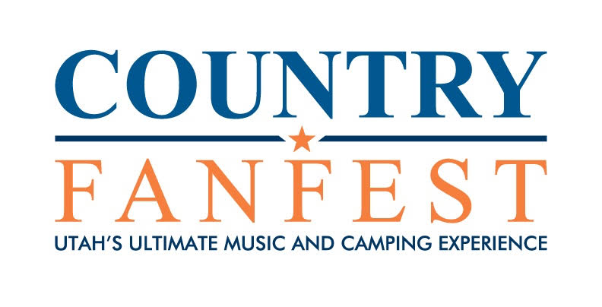
https://www.countryfanfest.com/
1st place guaranteed $200
February 18th at 09:00 AM
Bonwood Bowl
2500 S. Main St., South Salt Lake, UT
$30 per person
Mail entry forms to the tournament director or register online at Tournamentbowl.com
Tournament Director: Steven Vanderbloom (Cell) 435-841-7862
E-mail: svanderbloom77@yahoo.com
Address: 118 Tram Rock Rd., Lake Point, UT 84074
Name____________________________________________ Sex_______ USBC #___________________________
Address______________________________ City_________________________ ST_____ Zip_____________
Date of Birth___________________ Junior Gold YES NO
Phone_________________ Amount enclosed _______ E-Mail_________________________________________

Youth Open (USBC Cert. #07327)
ELIGIBILITY: Open to all USBC Youth members with a valid membership in good standing
DIVISIONS and FORMAT: This is a handicap tournament. All bowlers will bowl 4 games to determine placement. There will be 2 divisions. 0-149 Average and 150-300 Average. There will also be an optional scratch entry. Tournament will be using a sport compliant oil pattern.
AVERAGES: Bowlers will be assigned their composite average from the 22/23 season. If no 22/23 average, then the bowler will use their current average(MUST BRING A LEAGE STANDING SHEET). If a bowler does not have an average meeting the two previous methods, they will bowl scratch.
AVERAGE VERIFICATION: It is each bowler’s responsibility to verify his/her own submitted average as printed on the scoresheet. Any bowler who does not report an incorrect average may be disqualified from the tournament.
HANDICAP: All bowlers will use 90% of 240
ENTRY FEES: Fee per Person - $30.00 Breakdown – Scholarship/prize fund $14.00, Lineage $14, Expense $2. 100% of prize/scholarship fund will be awarded. No Refunds – USBC Rule 314. Junior Gold entry fee is U18 $50, U15 $35, U12 $25. Optional Scratch entry is an additional $5.
BOWLER’S AREA: Only participants & tournament officials are permitted in the bowling area. Food & drink will be permitted during competition outside of the bowler’s area.
DRESS CODE: All participants may wear casual slacks, trousers, jeans, skorts or shorts. All participants are required to wear a shirt with sleeves. Collared or Mock Collared shirts are preferred. Unacceptable attire includes, but not limited to: Tank tops, bare midriffs, workout attire, lounge pants, bib overalls, jeans that are torn, hats or attire with inappropriate, or offensive language or graphics. The tournament management will have final decision on all dress code related issues and reserves the right to require any participant to change any article of clothing determined not appropriate for tournament participation. If bowler refuses to change once requested, bowler will be disqualified and forfeit entry fee for the event of occurrence.
SCHOLARSHIPS AWARDS: Scholarship Prize Fund will be paid out at a 1:4 ratio. $200 Guaranteed to each divisions winner.
Junior Gold Qualifier – This event will be a Junior Gold Qualifier. Bowlers will use their scratch score for the tournament for qualification in their age division. Tournament organizer has the right to combine divisions if needed. U18, U15, and U12 will advance at a 1 to 4 ratio. In case of a tie there will be a 10th frame roll off. If the score is still tied, bowlers will bowl one shot at a time until the tie is broken with the highest pin count advancing.
Any disputes must be brought to the tournament officials on site at the time of occurrence and will be settled at that time. All protests and appeals must be in accordance with USBC Rule 329. Anything not covered within the tournament rules will be governed by tournament management and USBC national playing rules.
WALK-INS ARE ALLOWED AS SQUAD SIZE AND LANE AVAILABILITY PERMITS – WALK-INS MUST REGISTER AT LEAST 30 MINUTES PRIOR TO START OF ANY SQUAD TIME

